**HTML Task Day-2**

**Task1**

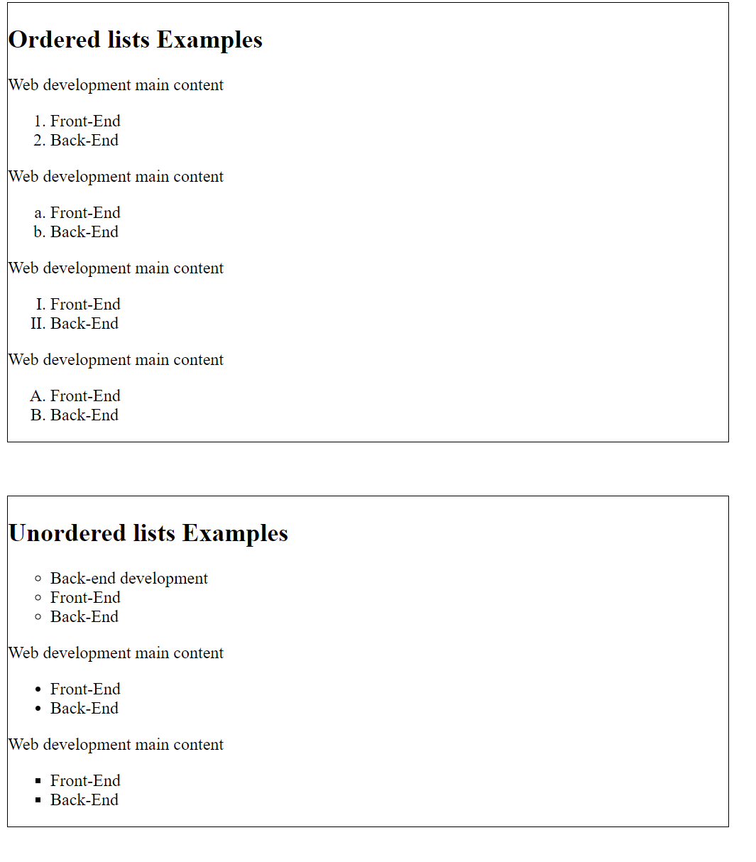

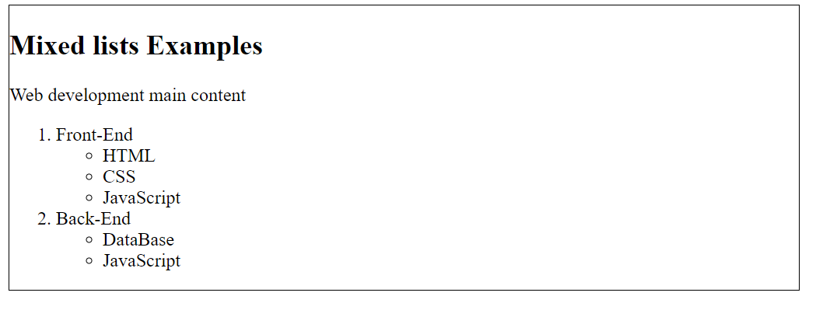

**Task2**

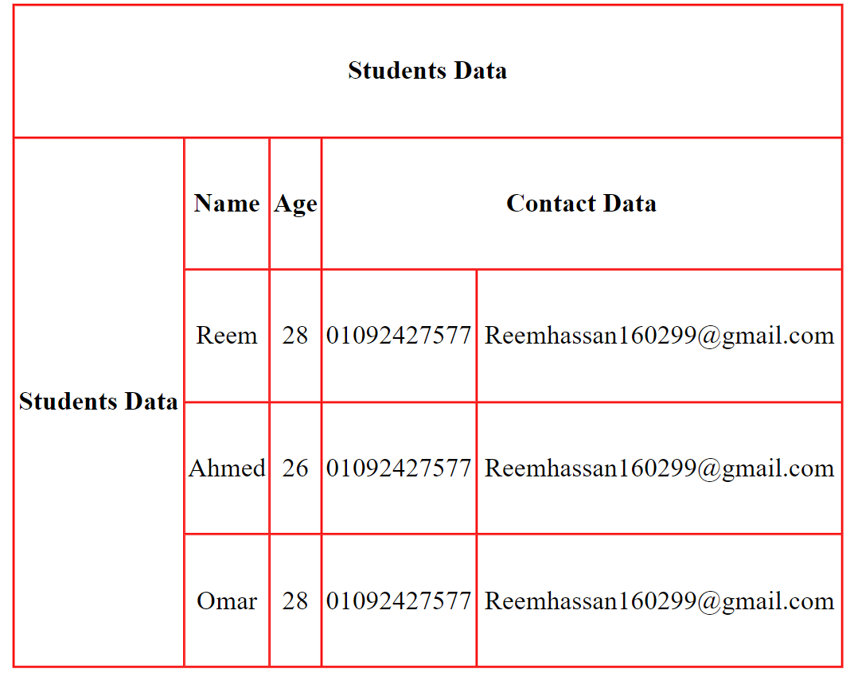

**Task3**

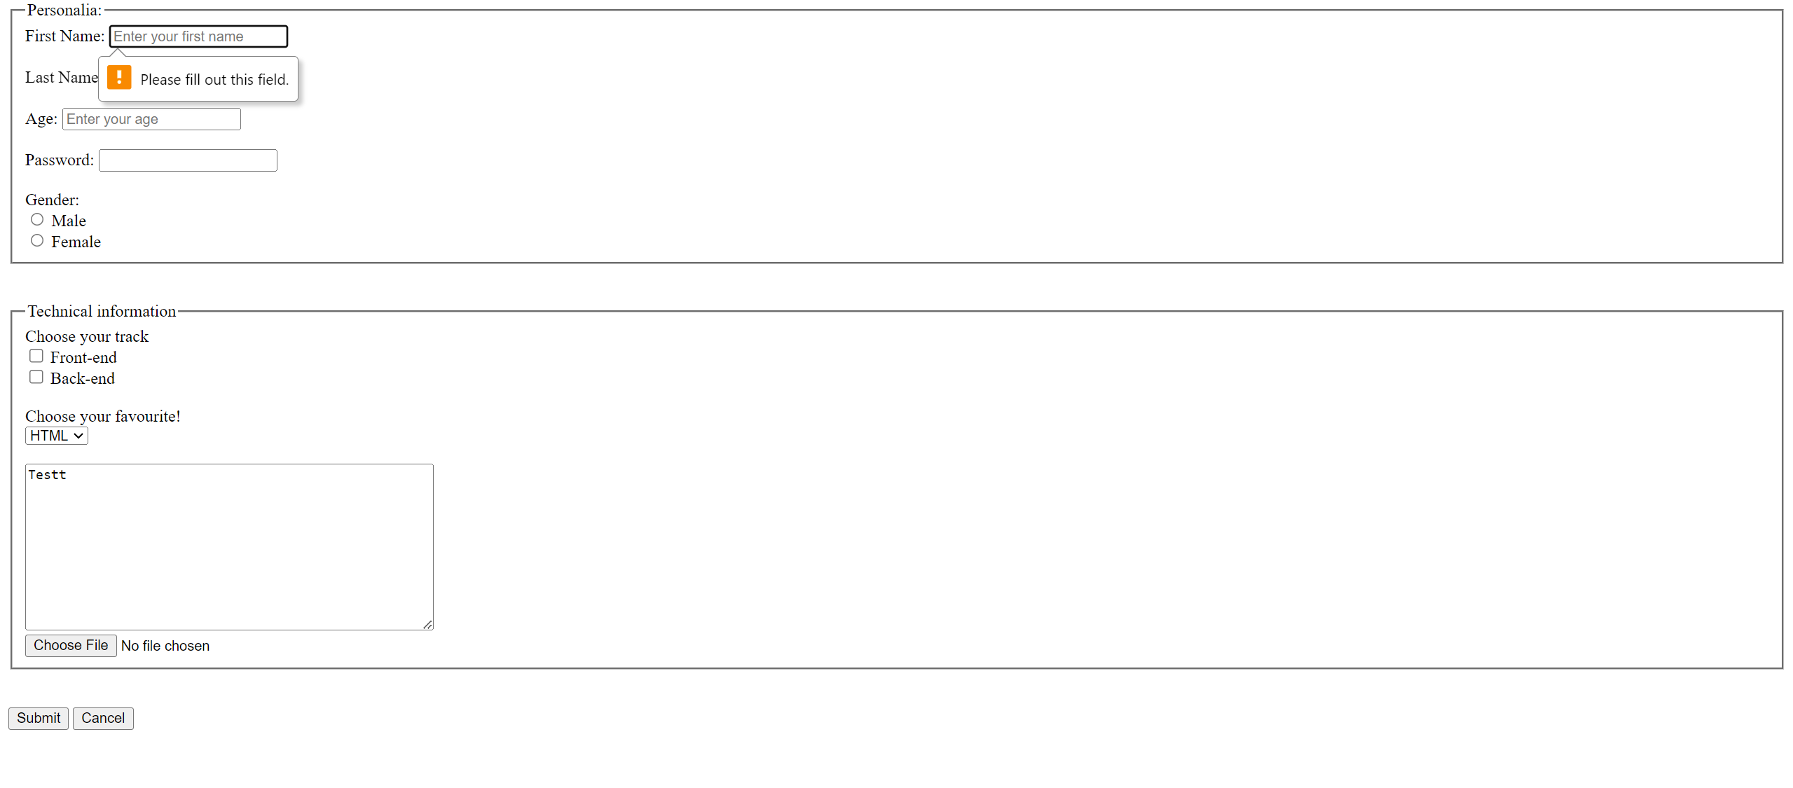

**Create the following HTML page with the following restrictions:**

* Each text input has a short hint (gray text) that guides the user what to enter in this field
* First name field is mandatory
* Last name field doesn’t allow the user to write data into it
* Age field only accepts 2 numbers